Change to TDL TO, part 4: Allow Entity to reference ComponentInstance

This change proposes an extension to EntityReference so that it may reference a ComponentInstance as an alternative to reference a locally defined Entity.
This document defines the changes the TDL TO part 4 document to introduce this change.

Modifications to TDL TO document sections to support the ComponentInstance reference

Changes to Section 5.4
Replace the Figure 5.3 “Events Concepts” with Figure 1 where the EntityReference may either refer to a ComponentInstance or an Entity.
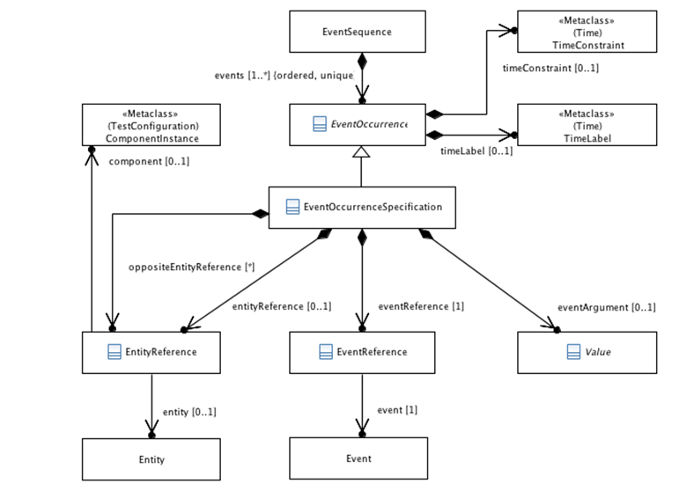
Figure 1: Events Concepts

Modify section 5.3.5 “EntityReference”
Add the following paragraph to the “Semantics” subsection:
Alternatively, an 'EntityReference' may be used to reference a 'ComponentInstance' of a 'TestConfiguration' instead of an 'Entity'.
Modify properties subsection:

Properties
- entity : Entity [0..1]
The referenced 'Entity'.
- component : ComponentInstance [0..1]
The referenced 'ComponentInstance'.
Add to Constraints subsection:
- An 'Entity' or a 'ComponentInstance' shall be referenced.
There shall be a reference to an 'Entity' or a 'ComponentInstance' but not both.
inv: EntityOrComponentInstance:
(not self.entity.oclIsUndefined() and self.component.oclIsUndefined())
or (self.entity.oclIsUndefined() and not self.component.oclIsUndefined())

Changes to Section 6.3.5 EntityReference
Change the “Formal Description” subsection as indicated below:
EntityReferenceLabel ::= self.comment->first() as context in <ArticleQualifier>
[foreach c:Comment in self.comment c as context in <Qualifier> end]
If self.component.oclIsUndefined() then
self.entity.name 'entity'
else
self.component.name 'component'
endif

OppositeEntityLabel ::= self.comment->first() as context in <DirectionQualifier>
self.comment->at(1) as context in <ArticleQualifier>
[foreach c:Comment in self.comment c as context in <Qualifier> end]
If self.component.oclIsUndefined() then
self.entity.name 'entity'
else
self.component.name 'component'
endif

Change the “Example” subsection to:
the IUT entity
from the ItsNodeB component
in the location service buffer entity, for the ItsNodeB component

Modify B.2 Production Rules
Modify the production rules “EntityReference” and “OppositeEntityReference” as follows:
EntityReference | ::= | ArticleQualifier
 |  | { Qualifier }
 |  | ( ( Identifier 'entity' )
 |  | | ( Identifier 'component' ) ) ;
OppositeEntityReference | ::= | DirectionQualifier
 |  | ArticleQualifier
 |  | { Qualifier }
 |  | ( ( Identifier 'entity' )
 |  | | ( Identifier 'component' ) ) ;

